Wednesday, April 19 at 7 pm. in Cheray 111
A Quebec film Screening (in French with English subtitles): Noir (Nwa)
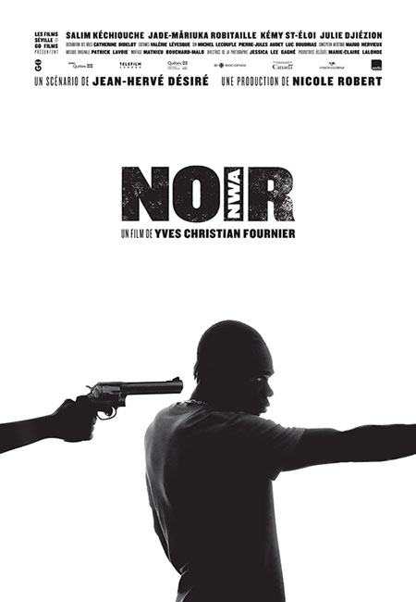
The film will be introduced by Sydney D Rybicki, double major in French and Spanish and Secretary of Student Life.
Contact: Prof. Laurence Clerfeuille <lclerfeuille@smcvt.edu>
